**DANIEL RODRIGUEZ SANCHEZ**

**MacOS**

* How many packets were transferred between the source and destination **(5%)**

20 packets were transferred

* What is the type for the request packets and what for a reply packet **(5%)**

The type of both, request and reply packages are ICMP

* Write the MAC address of the network card on the destination computer **(5%)**

74:ac:b9:54:18:d7

* How many bytes are in the field "Data" and what is the content of this field **(5%)**

There are 48 bytes, the content of this field is just half decoded so we can just see those symbols and numbers at the right side.

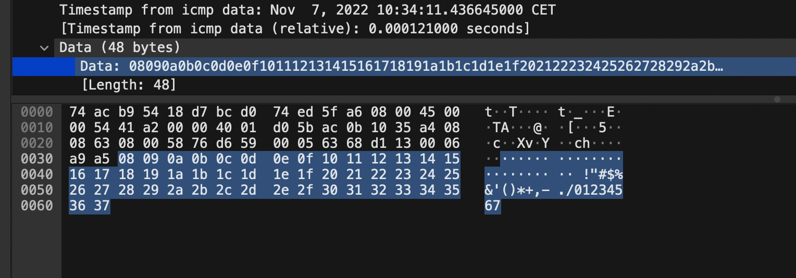

**WINDOWS**

* How many packets were transferred between the source and destination **(5%)**

20 packets were transfered

* What is the type for the request packets and what for a reply packet **(5%)**

Both of them use the ICMP protocol

* Write the MAC address of the network card on the destination computer **(5%)**

00:1c:42:00:00:18

* How many bytes are in the field "Data" and what is the content of this field **(5%)**

There are 32 bytes on the field data and the content of it are the first 23 letters from alphabet skipping “x”, “y” and “z” and completing until 32 bytes starting again from “a” to “i”.

* Comment on similarities and differences between running ping on Windows and Linux. Argument the differences:  
    
  Both use the ICMP to transmit the packets, the syntax is the same for both,   
  the output of the command is very similar in both OS.  
  These are the main similarities, however, when you access the content of the data field in Wireshark, you can see that in MacOS it occupies 48 bytes while in Windows just 32. Besides, in MacOS is just half decoded while in Windows you are able to see it all.

HTTP

* What is the IP address of your computer, the IP address of your server and the HTTP protocol version?  
    
  IP address of computer: 192.168.1.175  
    
  IP address of server: 45.33.7.16

HTTP protocol version: HTTP/1.1



* In which languages does your web browser try to receive the site content? What is the name of the HTTP field where the languages are defined?  
    
  Languages: Spanish from Spain(es-ES) and Spanish

Name of HTTP field: Accept-Language



* How many bytes were transferred to your computer (this includes HTML, CSS, JavaScript, Flash, images, ...)? How much time (in seconds) passed since the first request of your web browser, to the last transferred content?

Bytes transferred: 0.62MB  
  
Time passed: 8.638s



* Which status codes and how many of them were returned by the server?  
    
  The server only returned successful responses with status code 200. It returned 363 responses.  
    
  Tabla

  Descripción generada automáticamente



* Using Wireshark, create a flow graph for the captured packets and give a comment on what can be seen from the flow graph  
    
  Imagen que contiene Gráfico de rectángulos

  Descripción generada automáticamente  
  From the flow graph we can see every request and response from the communication, the addreses, the ports used, the time when they were sent, the content of the packets…

ESTIMATING THE TIME OF HTTP DATA TRANSFER

**Non-persistent connection:** 460ms  
**Non-persistent connection with parallel connections:** 306,36ms  
**Persistent connection without pipelining:** 456ms  
**Persistent connection with pipelining:** 183ms